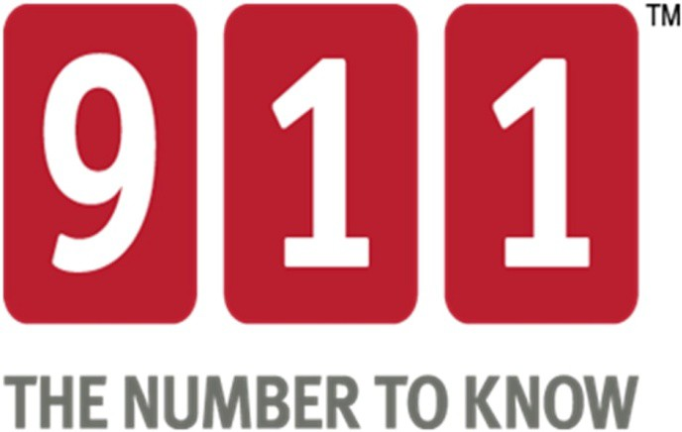

Public Relations Toolkit

2023

THE NATIONAL ASSOCIATION of STATE 911 ADMINISTRATORS

About the Toolkit
This Public Relations Toolkit was developed to accompany the 911 The Number to Know TM national awareness campaign. The campaign was developed for use by national organizations, state 911 entities, regional authorities and PSAPs during National 911 Education Month and National Public Safety Telecommunicators Week, both in April. It is also designed to support the coordinated promotion of 911 education and awareness year-round.

The National Association of State 911 Administrators (NASNA) has assumed responsibility for this toolkit. We hope it will provide you with useful information and ideas about how to celebrate and promote April as National 911 Education Month and National Public Safety Telecommunicators Week the second week of April. Additionally, a variety of campaign materials and templates have also been developed and are available for you to download at www.know911.org.

About National Association of State 911 Administrators
The National Association of State 911 Administrators (NASNA) is the voice of the states on public policy issues impacting 911. State 911 leaders’ expertise can assist industry associations, public policymakers, the private sector, and emergency communications professionals at all levels of government as they address complex issues surrounding the evolution of emergency communications. Our main areas of focus are:

- Developing productive partnerships with key organizations and individuals who share our interests

- Serving as an information sharing and support network for state 911 program administrators

- Strengthening relationships with federal lawmakers and agencies

For more information about NASNA, please visit us at www.NASNA911.org

Table of Contents
9-1-1 Origin & History 1
History of 911 Timeline 3
History of National 911 Education Month 4
Congressional Resolution 5
2022 Proclamation 6
National Public Safety Telecommunicators Week (April 10-16, 2022) 7
Ideas to Celebrate & Observe National 911 Education Month 10
News Conference Planning Guidelines 11
Sample News Release 12
Sample Media Advisory 14
Sample Talking Points for News Interviews 15
Logo Files for Printed Material 17
Collateral - Materials Resources - Fact Sheets 18

9-1-1 Origin & History
The three-digit telephone number "9-1-1" has been designated as the "Universal Emergency Number," for citizens throughout the United States to request emergency assistance. It is intended as a nationwide telephone number and gives the public fast and easy access to a Public Safety Answering Point (PSAP).
- In the United States, the first catalyst for a nationwide emergency telephone number was in 1957, when the National Association of Fire Chiefs recommended use of a single number for reporting fires.
- In 1967, the President's Commission on Law Enforcement and Administration of Justice recommended that a "single number should be established" nationwide for reporting emergency situations. The use of different telephone numbers for each type of emergency was determined to be contrary to the purpose of a single, universal number.
Other Federal Government Agencies and various governmental officials also supported and encouraged the recommendation. As a result of the immense interest in this issue, the President's Commission on Civil Disorders turned to the Federal Communications Commission (FCC) for a solution.
- In November 1967, the FCC met with the American Telephone and Telegraph Company (AT&T) to find a means of establishing a universal emergency number that could be implemented quickly. In 1968, AT&T announced that it would establish the digits 9-1-1 (nine-one-one) as the emergency code throughout the United States.
- The code 9-1-1 was chosen because it best fit the needs of all parties involved. First, and most important, it met public requirements because it is brief, easily remembered, and can be dialed quickly. Second, because it is a unique number, never having been authorized as an office code, area code, or service code, it best met the long range numbering plans and switching configurations of the telephone industry.
- Congress backed AT&T's proposal and passed legislation allowing use of only the numbers 9-1-1 when creating a single emergency calling service, thereby making 9-1-1 a standard emergency number nationwide. A Bell System policy was established to absorb the cost of central office modifications and any additions necessary to accommodate the 9-1-1 code as part of the general rate base.
- With Enhanced 9-1-1, or E9-1-1, local PSAPs are responsible for paying network trunking costs according to tariffed rates, and for purchasing telephone answering equipment from the vendor of their choice.
- On February 16, 1968, Senator Rankin Fite completed the first 9-1-1 call made in the United States in Haleyville, Alabama. The serving telephone company was then Alabama Telephone Company. This Haleyville 9-1-1 system is still in operation today.
- On February 22, 1968, Nome, Alaska implemented 9-1-1 service.
- In March 1973, the White House's Office of Telecommunications issued a national policy statement which recognized the benefits of 9-1-1, encouraged the nationwide adoption of 9-1-1, and provided for the establishment of a Federal Information Center to assist units of government in planning and implementation.
The intense interest in the concept of 9-1-1 can be attributed primarily to the recognition of characteristics of modern society, i.e., increased incidences of crimes, accidents, and medical emergencies, inadequacy of existing emergency reporting methods, and the continued growth and mobility of the population.
- In the early 1970s, AT&T began the development of sophisticated features for the 9-1-1 with a pilot program in Alameda County, California. The feature was "selective call routing." This pilot program supported the theory behind the Executive Office of Telecommunication's Policy.
- By the end of 1976, 9-1-1 was serving about 17% of the population of the United States. In 1979, approximately 26% of the population of the United States had 9-1-1 service, and nine states had enacted 9-1-1 legislation. At this time, 9-1-1 service was growing at the rate of 70 new systems per year. By 1987, those figures had grown to indicate that 50% of the US population had access to 9-1-1 emergency service numbers.
- In addition, Canada recognized the advantages of a single emergency number and chose to adopt 9-1-1 rather than use a different means of emergency reporting service, thus unifying the concept and giving 9-1-1 international stature.
- At the end of the 20th century, nearly 93% of the population of the United States was covered by some type of 9-1-1 service. Ninety-five percent of that coverage was Enhanced 9-1-1. Approximately 96% of the geographic US is covered by some type of 9-1-1.

(9-1-1 Origin & History provided by NENA)

History of 911 Timeline

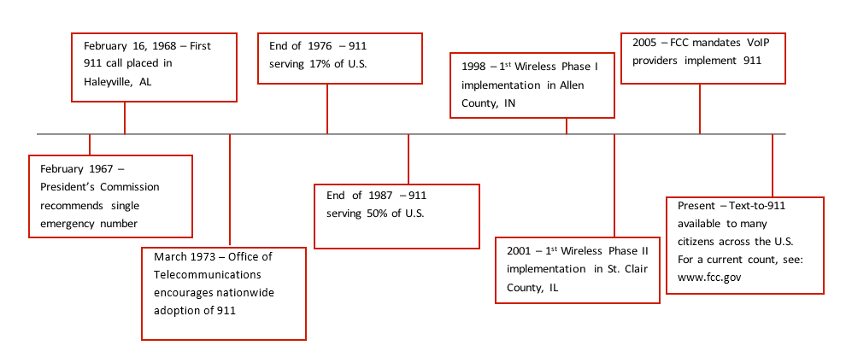

History of National 911 Education Month
In 2008, the United States Congress recognized April as National 911 Education Month. The National 911 Education Coalition has disbanded and the National Association of State 911 Administrators (NASNA) has assumed responsibility for the materials housed in the Know911.org website. NASNA calls upon public safety officials, schools, government officials and industry leaders to engage in a national effort to educate children, seniors and the general public about the importance and appropriate use of 911. During the month of April, these organizations conduct special outreach to build on existing state and local 911 education efforts in an attempt to raise the issue of 911 education to a national level.

Congressional Resolution
Congress first endorsed April as National 911 Education Month in March 2008. The Congressional NextGen 911 Caucus Co-Chairs Reps. Anna Eshoo (D-CA) and John Shimkus (R-IL) and 56 House con sponsors sponsored H-Res. 537 to establish April as National 911 Education Month and enable Congress to support a national effort by the National 911 Education Coalition dedicated to advancing public safety. In April 2010, the United States Senate passed S-Res. 482 recognizing April as “National 911 Education Month.” The Measure was co-sponsored by the NextGen 911 Caucus Co-Chairs Amy Klobuchar (D-MN) and Senator Richard Burr (R-NC) in support of the Coalition’s efforts and urging the public to observe the month with appropriate ceremonies, training activities, and education efforts.

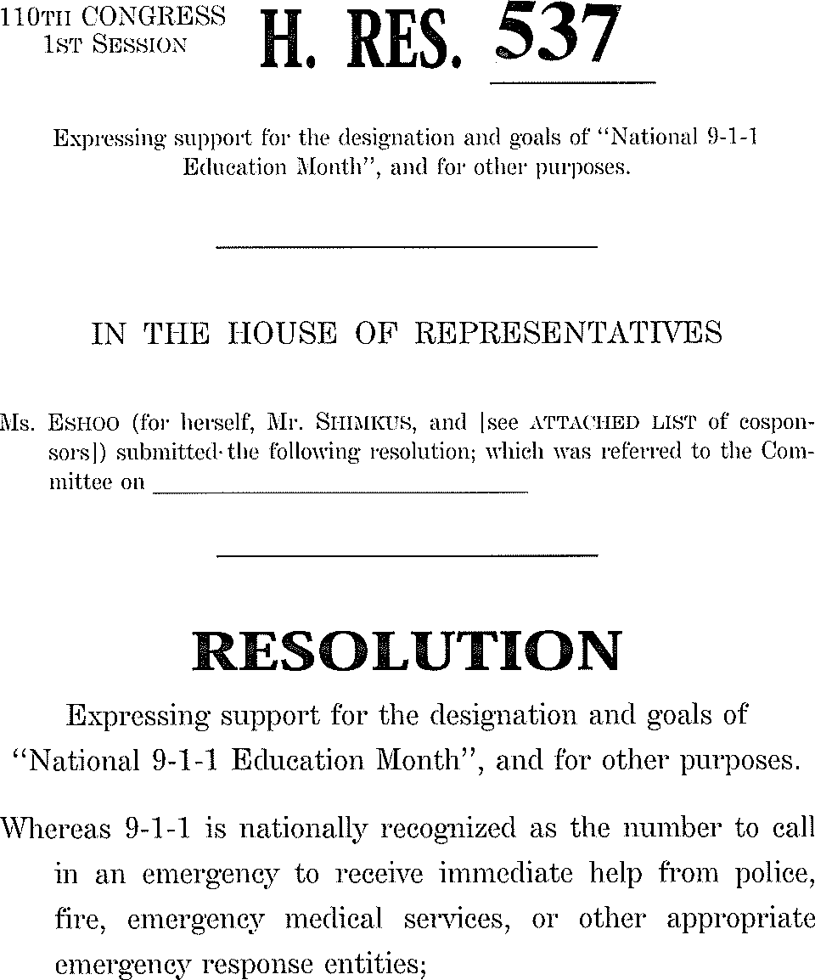 | 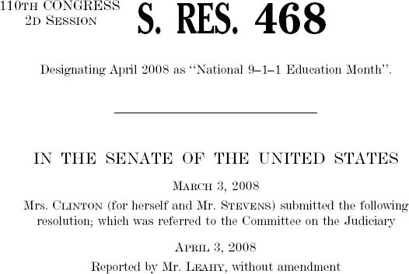

2023 Proclamation
PROCLAMATION
National 911 Education Month
April 2023
WHEREAS, 911 is nationally recognized as the number to call in an emergency to receive immediate help from police, fire, emergency medical services, or other appropriate emergency response entities; and
WHEREAS, 911 was designated by Congress as the national emergency call number under the Wireless Communications and Public Safety Act of 1999 (Public Law 106-81); and
WHEREAS, the ENHANCED 911 Act of 2004 (Public Law 108-494) established enhanced 911 as a high national priority as part of our Nation's homeland security and public safety; and
WHEREAS, people of all ages use 911, and it is critical to educate the public of all ages on the proper use of 911; and
WHEREAS, a growing segment of the population, including the deaf, hard of hearing, deaf-blind, and individuals with speech disabilities increasingly communicate with nontraditional text, video and instant messaging communications services and anticipate that these services will be able to connect directly to 911; and
WHEREAS, thousands of 911 calls are made every year by children properly trained on the use of 911, resulting in lives saved which underscores the critical importance of training children early in life about 911; and
WHEREAS, there is widespread misuse of the 911 system, including prank and non-emergency calls, which can result in costly and inefficient use of 911 and emergency response resources.
NOW, therefore, I, [First/Last Name], Mayor of [City/County], do hereby proclaim April 2023 as National 911 Education Month. I call upon all government officials, parents, teachers, school administrators, caregivers, businesses leaders, non-profit organizations, and the people of the United States to observe this month with training, events, and activities to educate the public on 911 and its services.
Dated this day of April, 2023
[First/Last Name], Mayor

Attest:
[First/Last Name], Clerk
(Attachment 3)

National Public Safety Telecommunicators Week
(April 9-15, 2023)
Celebrate National Public Safety Telecommunicators Week (NPSTW) the second full week of April; April 9-15, 2023. NPSTW is celebrated annually and honors the thousands of men and women who respond to emergency calls, dispatch emergency professionals and equipment, and render lifesaving assistance to the citizens of the United States.

It was first conceived by Patricia Anderson of the Contra Costa County (Calif.) Sheriff's Office in 1981 and was observed only at that agency for three years. Members of the Virginia and North Carolina chapters of the Association of Public-Safety Communications Officials (APCO) became involved in the mid-1980s. By the early 1990s, the national APCO organization convinced Congress of the need for a formal proclamation. Rep. Edward J. Markey (D-Mass.) introduced what became H.J. Res. 284 to create "National Public Safety Telecommunicators Week." According to Congressional procedure, it was introduced twice more in 1993 and 1994, and then became permanent, without the need for yearly introduction.

The official name of the week when originally introduced in Congress in 1991 was "National Public Safety Telecommunicators Week." In the intervening years, it has become known by several other names, including "National Public-Safety Telecommunications Week" and "International Public Safety Telecommunicator's Week." The Congressional resolution also stated there were more than "500,000 telecommunications specialists," although other estimates put the number of 911 operators at just over 200,000. The Congressional figure may include support personnel and, perhaps, even those in the commercial sector of public safety communications.

Of course, you don't need NPSTW to honor your public safety dispatchers for their hard work and excellence! You can write them a commendation, mention their "good job" at a shift briefing, or just give them a pat on the back.

HISTORY NPSTW – 1991
NATIONAL PUBLIC SAFETY TELECOMMUNICATORS WEEK
(House of Representatives – October 09, 1991)

The Clerk read the joint resolution, as follows:

H.J. Res. 284

Whereas over one-half million dedicated men and women are engaged in the operation of emergency response systems for Federal, State, and local governmental entities throughout the United States;

Whereas these individuals are responsible for responding to the telephone calls of the general public for police, fire, and emergency medical assistance and for dispatching said assistance to help save the lives and property of our citizens;

Whereas such calls include not only police, fire, and emergency medical service calls but those governmental communications related to forestry and conservation operations, highway safety and maintenance activities, and all of the other operations which the modern governmental agency must conduct; and

Whereas America's public safety telecommunicators daily serve the public in countless ways without due recognition by the beneficiaries of their services: Now, therefore, be it

Resolved by the Senate and House of Representatives of the United States of America in Congress assembled, That the second week in April is hereby designated as 'National Public Safety Telecommunicators Week'. The President is authorized and requested to issue a proclamation calling upon the people of the United States to observe that week with appropriate ceremonies and activities.

AMENDMENT IN THE NATURE OF A SUBSTITUTE OFFERED BY MR. SAWYER

Mr. SAWYER. Mr. Speaker, I offer an amendment in the nature of a substitute.

The Clerk read as follows:

Amendment in the nature of a substitute offered by Mr. Sawyer: Strike all after the resolving clause and insert the following:

That the week beginning April 12, 1992, is designated as ‘National Public Safety Telecommunicators Week’, and the President is authorized and requested to issue a proclamation calling on the people of the United States to observe the week with appropriate ceremonies and activities.

The SPEAKER pro tempore. The question is on the amendment in the nature of a substitute offered by the gentleman from Ohio [Mr. Sawyer].

The amendment in the nature of a substitute was agreed to.

The joint resolution was ordered to be engrossed and read a third time, was read the third time, and passed.

TITLE AMENDMENT OFFERED BY MR. SAWYER

Mr. SAWYER. Mr. Speaker, I offer an amendment to the title.

The Clerk read as follows:

Title amendment offered by Mr. Sawyer: Amend the title so as to read: ‘To designate the week beginning April 12, 1992, as ‘National Public Safety Telecommunicators Week’.’

The title amendment was agreed to.

A motion to reconsider was laid on the table.

Ideas to Celebrate & Observe National 911 Education Month

Host a 911 Education Kickoff with a Local School
- Hold an assembly to instruct children on how to use 911 and the appropriate use of 911
- Invite children to interact with Public Safety Officials
- Invite a local school to a PSAP visit
- Hold games and activities

Host a News Conference
- Highlight 911 Education
- Recognize local 911 Heroes
- Highlight National Public Safety Telecommunicators Week the second week of April

Host a PSAP Open House
- Provide the community a closer look at the Public Safety System and the people on the receiving end of the 911 call

Recognize Public Safety Dispatchers
- Host a joint celebration of National 911 Education Month and National Public Safety Telecommunicators Week the second week of April

Inform the Public
- Place an information booth in a high traffic location such as a Government Building, Town Hall or at a local event – could be a manned or unmanned booth
- Provide collateral and information
- Use County and Public Access channels to notify the public of the booth and available information

News Conference Planning Guidelines

Preliminary Actions
- Determine location, time and date
- Notify local media of conference location and time
- Identify and confirm space
- Identify and confirm speakers
- Produce media kit or other necessary information
- Arrange for video and/or audio taping
- Make follow up calls to media
- Arrange reception area for media
- Brief your staff on the subject, spokesperson and the schedule

Statements and News Releases
- Obtain written statements from the spokesperson
- Make copies of the news release available to media
- Develop anticipated questions and answers for the spokesperson
- Assemble press kits that include background information

News Conference
- Prepare media kits for handout
- Record the names and contact information for media member attendance
- Monitor the time and pace of the conference closely
- Prepare conference notes

Conference Follow-Up
- Send thank you to VIPs
- Send pictures of the news conference to local media
- Monitor media for news conference coverage

Sample News Release
Note to sender: please remove from document before distribution:
*This release announces April as National 911 Education Month and should be sent anytime between March 15 and April 30, 2023
*This release is available for PSAPs to distribute to local news media
*Please include appropriate spokesperson name and title to provide attribution to the generic quotes included below

[Agency/Organization Logo/Letterhead]

FOR IMMEDIATE RELEASE CONTACT: [Name]
[Date] [Phone number]
[Email Address]

National 911 Education Month Prepares Americans for Emergencies

[City, State] – This April 1 – 30, national public safety organizations and the wireless industry will conduct outreach to the community to ensure the public is ready to access help during emergencies during National 911 Education Month.

A variety of resources are available at www.know911.org to support both the “911, The Number to Know” campaign and education themes including:

Call If You Can, Text If You Can’t: Text-to 911 service is available in an increasing number of communities around the country. The service benefits individuals (or persons) who are deaf, hard of hearing or in a situation where they cannot speak and make a voice call. However, a traditional voice call, if possible, is still the best way to reach emergency services.

Know Your Location: Wireless calls to 911 provide location information, but 911 call-takers may need more specific information. Be prepared to provide detailed information on where you are so that help can get to you as quickly as possible.

Stay Calm and Don’t Hang Up: Until you are instructed to do otherwise, stay on the line so you can provide any necessary information or assistance to the 911 call-taker. Even if you accidentally call 911, don’t hang up. Inform the call-taker that you dialed accidentally and that there is no emergency.

“For nearly five decades, 911 has served as the vital link between the American public and emergency services. Public education and awareness initiatives have contributed in large measure to this incredible success,” said , . “The resources available at www.know911.org help educators, government officials, media representatives, and concerned citizens alike promote ongoing, age-appropriate 911 education that can save lives.”

“You don’t wake up in the morning thinking you are going to call 911. However, should you have to, it may be the most important call you ever make,” said , .

“That’s what makes National 911 Education Month so very important. In an emergency, seconds matter; being knowledgeable and prepared can make all the difference.”

# # #

Sample Media Advisory
[Agency/Organization Logo/Letterhead]

MEDIA ADVISORY FOR

CONTACT: [Name]
[Date of Event] [Phone number]
[Email Address]

[Name of Town/City/County]
[Name of Participants] Rev Up for Celebration of
April as National 911 Education Month

[Name of Participants of Town/City/County] will join millions of their peers across the country during the month of April to celebrate National 911 Education Month on [Date of Event] at [Location of Event].

[Local Public Safety Entity] has joined the national efforts of the 911: The Number to Know awareness campaign launched by the National 911 Education Coalition and now sustained by the National Association of State 911 Administrators to help citizens of all ages recognize the importance of 911 and their role when calling.

[Local Public Safety Entity] will host [Event Title] to join the national efforts to educate the public.

WHO:
WHAT:
WHEN:
WHERE:
WHY:

[Insert Information on Local Public Safety Entity Here. For more information, visit [{website}]

Sample Talking Points for News Interviews

Developing Talking Points:
Creating A Road Map for Your Media Interview

Once a media interview is secured, the key campaign messages (the most important information you want the viewer to recall after the interview) should be reviewed, and talking points developed to help your 911 representative incorporate that important information into the interview.

A variety of sample key messages can be found at know911.org/ message-guidelines. For example, sample key messages for a “911: The Number to Know” campaign theme might include:

- Call If You Can, Text If You Can’t: Text-to-911 service is available in an increasing number of communities around the country. The service benefits individuals (or persons) who are deaf, hard of hearing or in a situation where they cannot speak and make a voice call. However, a traditional voice call, if possible, is still the best way to reach emergency services.

- Know Your Location: Wireless calls to 911 provide location information, but 911 call-takers may need more specific information. Be prepared to provide detailed information on where you are so that help can get to you as quickly as possible.

- Stay Calm and Don’t Hang Up: Until you are instructed to do otherwise, stay on the line so you can provide any necessary information or assistance to the 911 call-taker. Even if you accidentally call 911, don’t hang up. Inform the call-taker that you dialed accidentally and that there is no emergency.

Talking points should make these three main points more “real” by including information specific to your community, such as anecdotes, success stories, and conversational phrases.

The reporter or editor will either be open to suggestions about a location and interview opportunities, or will already have suggestions about how they would like to build the segment. Incorporating people who have successfully used 911 to help save a life (their own or others) is an additional way to communicate a good outcome and bring the campaign messages “to life,” helping you and the reporter create an interesting story for the viewer.

Talking points should:

- Be brief. Most broadcast media interviews happen very quickly.

- Be conversational. Talking points should not be read verbatim, but should be personalized by the 911 representative participating in the interview.

- Be limited in quantity and prioritized. Again, broadcast interviews happen very quickly, so an interviewee should not expect to have the opportunity to communicate more than three to five messages in an interview.

- Incorporate the opportunity to “bridge” back to the key message. Reporters often take the interview away from the desired key messages. This is most often done without intent or malice, but good talking points and some pre-interview practice should help the interviewee take control of the segment and communicate those key messages, no matter that question the reporter asks.

- For example – A reporter asks about the specific technology involved in your 911 systems. Pre-interview talking points can include a few suggestions such as:

- “That’s a great question. We have very modern technology which allows us to help the people who call; however, even the best technology available to us right now can’t tell us exactly where a caller is, which is why we rely on the caller to be sure they provide exact information about their location so the police, fire or EMS team can find and help them.”

- “I’m glad you asked that! We use current technology to help us find people who call 911; however, the technology that is available through applications in the private sector isn’t always available through the 911 system. And since location is critical to 911, we always confirm with the caller to be sure we have accurate information about their location so the police, fire or EMS team can find and help them.”

Logo Files for Printed Material

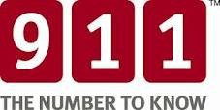

The National Association of State 911 Administrators (NASNA) encourages organizations to use the campaign logo and tagline as an anchor to your own materials, not as the main focal point. Suggested placement is at the bottom of your piece, next to your own organization’s logo(s). The campaign logo can be used in printed pieces and ads, in PowerPoint slide presentations, in television ads, on videos, websites, and on T-shirts or other promotional items. You are limited only by your imagination.

The campaign logo and tagline are the intellectual property of NASNA; however, it is made available for use by 911 organizations, PSAPs, educators and anyone who promotes 911. We only ask that you do not alter the logo and follow the logo usage guidelines (see the Campaign Guide in the Resources section of the website). Use by commercial organizations requires prior written approval from NASNA.

The campaign logo and tagline are yours to use; however, we would love to see what you do with it. In the future we may share best practice examples of ways materials have been used to support local outreach efforts, but you do not need to have anything approved.

Please visit www.know911.org for more information regarding the logo. More information can be found in the Frequently Asked Questions section of the website as well as the Campaign Guide in the Downloadable Resources section of the website.

Collateral - Materials Resources - Fact Sheets
The National Association of State 911 Administrators: www.know911.org
The 911 Number to Know Campaign has free downloadable resources including graphics files, templates, educational materials, signage, web banners and more.

The Association of Public-Safety Communications Officials (APCO) International: www.apcointl.org
APCO International’s website contains information for the public regarding location, wireless phone calls to 911, and information that is needed by the 911 center. Other resources include Project Locate and standards for handling calls involving missing and exploited children. These and other APCO American National Standards can be accessed under the headings “Standards” and “Comm Center/9-1-1” on the website.

CTIA®: www.ctia.org
The CTIA website contains much information about wireless facts and safety. Go to www.ctia.org. Click on Consumer Resources for various topics.

The Industry Council for Emergency Response Technologies (iCERT): www.theindustrycouncil.org

NG9-1-1 Institute: www.ng911institute.org
Visit the NG9-1-1 Institute web site for information and resources to celebrate April
as National 911 Education Month and year-round coverage of 911 issues.

Denise Amber Lee Foundation: www.deniseamberlee.org
The Denise Amber Lee Foundation was created to offer and support uniform training in public safety, promote standardized protocols, define measurable outcomes pertaining to quality assurance, and support our industry partners through sharing technological advances to 911. The Foundation offers a variety of training sessions live and online, keynote speaker, third-party quality assurance, and much more.

National Association of State 911 Administrators: www.nasna911.org

International Academies of Emergency Dispatch (IAED): www.emergencydispatch.org

National Emergency Number Association (NENA): www.nena.org
The NENA website contains much information regarding basic 9-1-1 such as What is 9-1-1? What is Enhanced 9-1-1? Who Pays for 9-1-1? When Should You Use 9-1-1? and 9-1-1 Use and Guidelines and much more. Visit www.nena.org and go to the Stats link.

911 for Kids: www.911forkids.com
Available for purchase includes materials for children ages pre-K to teenagers as well as materials for adults and seniors. Visit www.911forkids.com to purchase materials.

National Center for Missing & Exploited Children: www.missingkids.org

